(Edsel Motors) Edsel Motors produces cars in Detroit and Dallas. The Detroit plant can produce up to 8500 cars, and the Dallas plant can produce up to 4000 cars. Producing a car costs $2000 in Detroit and $1800 in Dallas. Cars must be shipped to 12 cities. The costs of shipping a car from each plant to each city and the city requirements are given in the file **P05_57.xlsx**. At most 1000 cars can be sent from a given plant to a given city. Determine how to minimize the cost of meeting all demands.





**Discussion: -**

Below picture gives you how the production of each plant is planned, and shipping is done from each plant to each city. Our objective in this problem is to minimize the cost. As per the given problem, cost is dependent on the production cost and shipping cost between a plant and city. If we know the number of cars shipped from each plant to each city, we will be able to calculate the total cost. Hence our decision variable will be the number of cars shipped from each plant to each city.

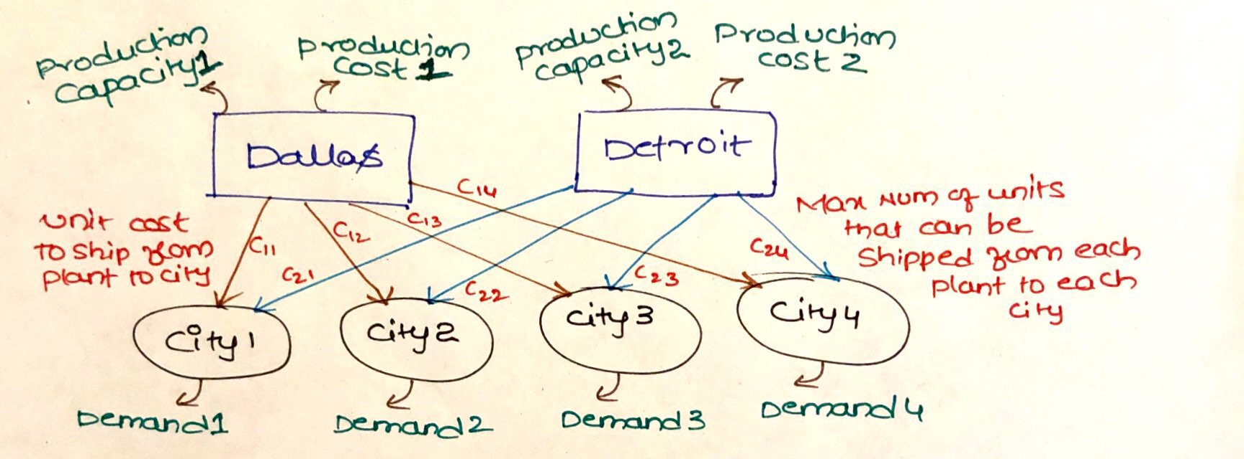

**Mathematical Model: -**

*Parameters (Inputs):*

$$i ϵ 1,2 \left( i: Index for production plants\right)$$

$$j ϵ 1,2,3..12 \left( j: Index for cities \right)$$

$$A_{ij} : Unit cost to ship a car from plant i to city j$$

$$C_{i} : Production cost at plant i$$

$$D_{j} : Demand in city j$$

$M : Maximum number of cars that can be shipped from each plant to each city;M=1000$

$$P_{i} : Production capacity at plant i$$

*Decision Variables:*

$$x_{ij} :Number of units shipped from plant i to city j$$

*Objective:*

$$Minimize total cost=\sum_{j=1}^{12}{\sum_{i=1}^{2}{\left(x_{ij}*A_{ij}\right)}}+\sum_{j=1}^{12}{\sum_{i=1}^{2}{\left(x_{ij}*C_{i} \right)}}$$

*Constraints:*

$$x_{ij}≥0; \left(1\right) Non Negative constraint$$

$$\sum_{j=1}^{12}{x_{ij}}≤P_{i} ; for i ϵ\left\{1,2\right\} \left(2\right) Production capacity constraint$$

$$\sum_{i=1}^{2}{x_{ij}}≥D_{j} ; for j ϵ\left\{1,2,..12\right\} \left(3\right) Demand Constraint$$

$$x_{ij}≤M; \left(4\right) Plant to city supply constraint$$

Constraint 2 will make sure that supply of each plant will not exceed the plant capacity. Constraint 3 will make sure that optimal solution meets the demand of each city. Constraint 4 helps in making sure that each plant can supply at max only 1000 vehicles to each city.

*Excel Implementation:* Please find the attached spreadsheet for solution.



